### **CHAPTER NO: 2**

**SOLUTION OF ALGEBRAIC &**

**TRANSCENDENTAL EQUATION**

**INTRODUCTION**

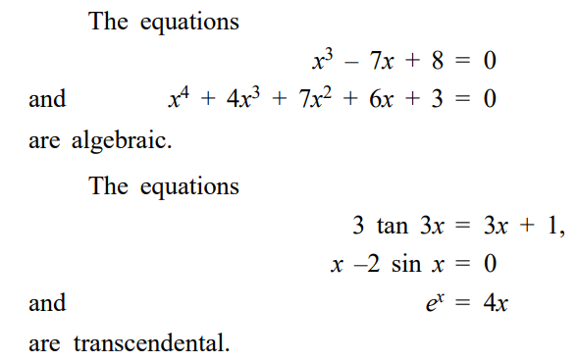Some numerical methods for solving algebraic and transcendental equations. The equation f (x) = 0 is said to be algebraic if f (x) is purely a polynomial in x. If f (x) contains some other functions, namely, Trigonometric, Logarithmic, Exponential, etc., then the equation f (x) = 0 is called a Transcendental Equation.

**Algebraically,** the real number α is called the real root (or zero of the function f (x)) of the equation f (x) = 0 if and only if f ( ) α = 0 and **geometrically** the real root of an equation f (x) = 0 is the value of x where the graph of f (x) meets the x-axis in rectangular coordinate system. We will assume that the equation

**f (x) = 0 -----------------**(1)

has only isolated roots, that is for each root of the equation there is a neighbourhood which does not contain any other roots of the equation.

**Approximately the isolated roots of the equation (1) has two stages.**

**1.** Isolating the roots that is finding the smallest possible interval (a, b) containing one and only one root of the equation (1).

**2.** Improving the values of the approximate roots to the specified degree of accuracy. Now we state a very useful theorem of mathematical analysis without proof.

# **1. METHOD OF BISECTION**

Such that **f(c) = 0** which means that c is a root of equation (1)

The **bisection method** is well suited to electronic computers. The method may be conveniently used in rough approximations of the root of the given equation. The bisection method is a simple but slowly convergent method.

# **2. THE ITERATION METHOD**

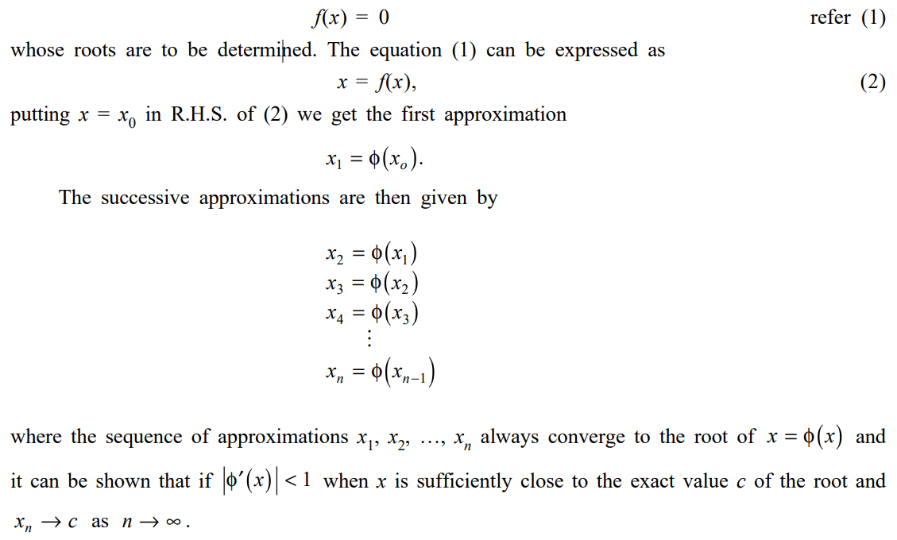Suppose we have an equation

**NOTE:**

1. The smaller the value of φ′(x) the more rapid will be the convergence.

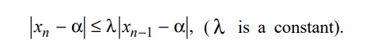 2. From (1) we have the relation

Hence the error at any stage is proportional to the error in the previous stage. Therefore the iteration method has a linear convergence.

3. Iteration method is more useful for finding the real roots of an equation which is in the form of an infinite series.

# **3. NEWTON–RAPHSON METHOD OR NEWTON ITERATION METHOD**

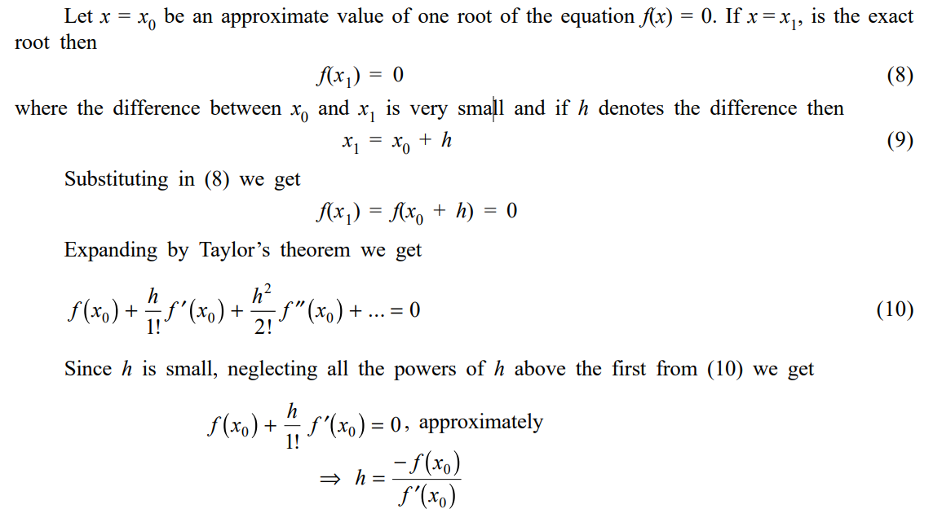This is also an iteration method and is used to find the isolated roots of an equation f(x) = 0, when the derivative of f(x) is a simple expression. It is derived as follows:

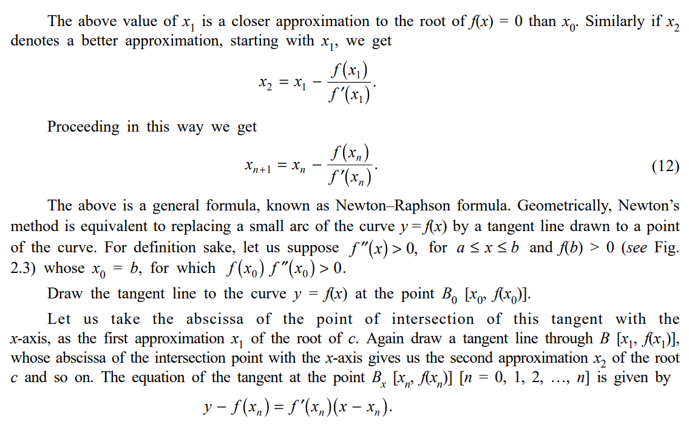

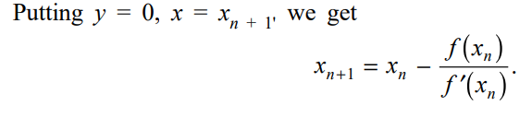

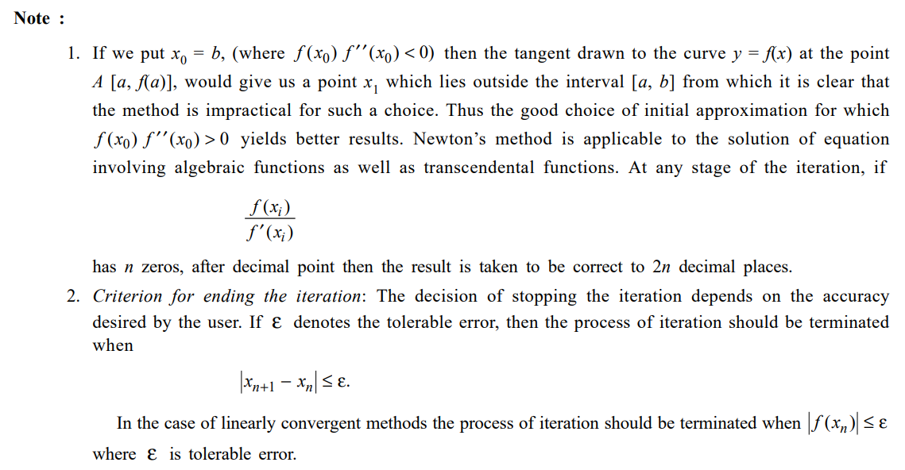

# **4. Convergence of Newton’s Method**

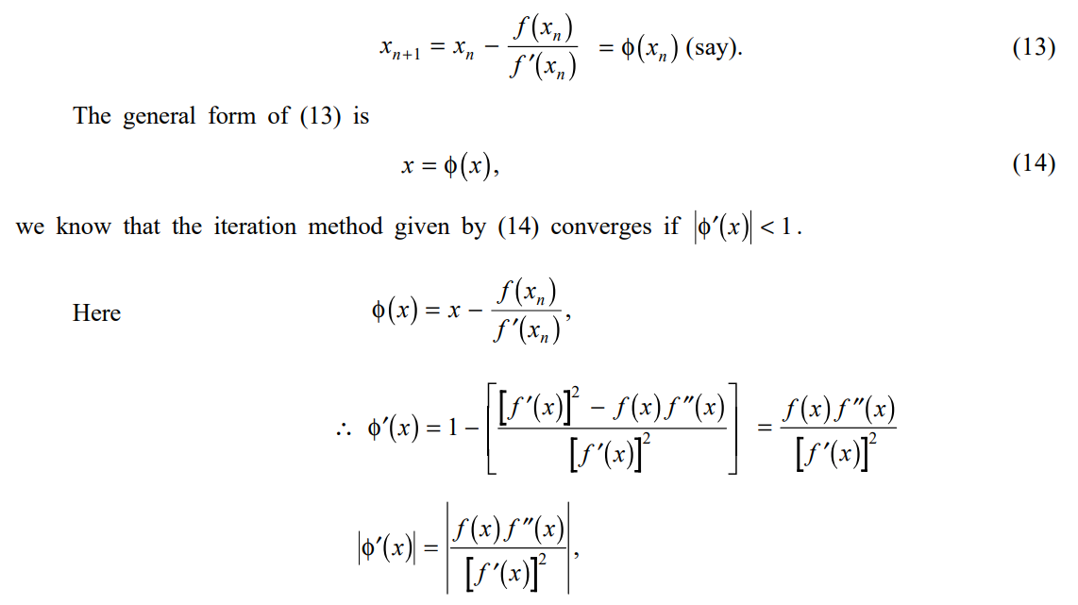**The Newton–Raphson formula is**

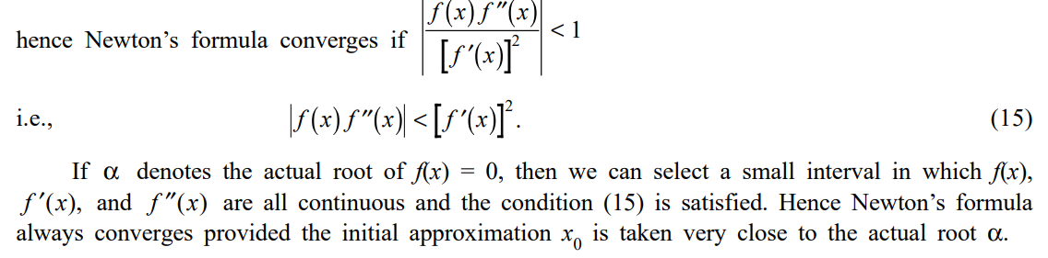

# **5. Rate of Convergence of Newton’s Method**

From (16) it is clear that the error at each stage is proportional to the sequence of the error in the previous stage. Therefore Newton–Raphson method has a quadratic convergence

**6. REGULA-FALSI METHOD**

Consider the equation f(x) = 0 and let a, b be two values of x such that f(a) and f(b) are of opposite signs. Also let a < b. The graph of y = f(x) will meet the x-axis at the same point between a and b. The equation

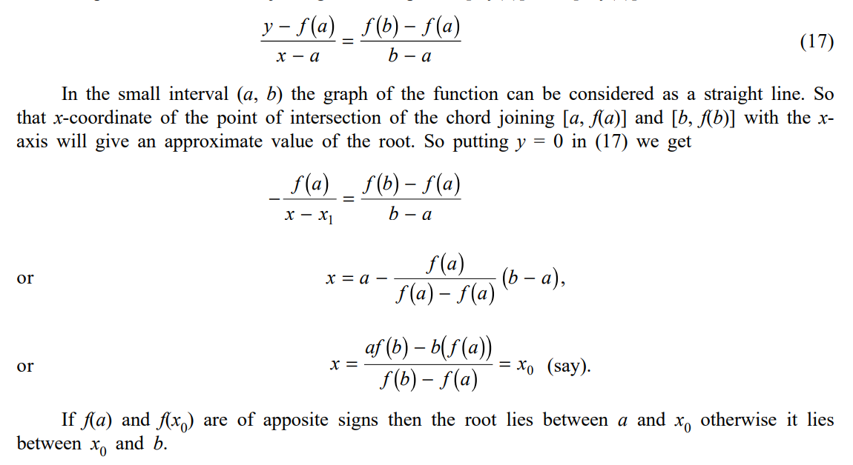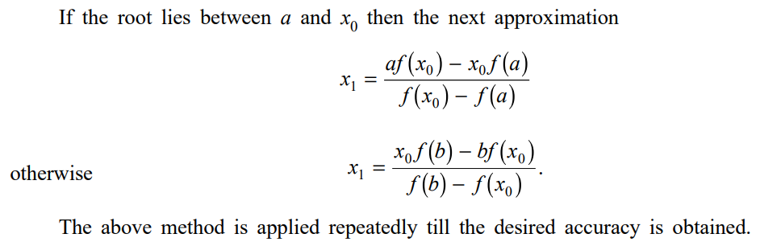of the chord joining the two points [a, f(a)] and [b, f(b)] is